Answer 1
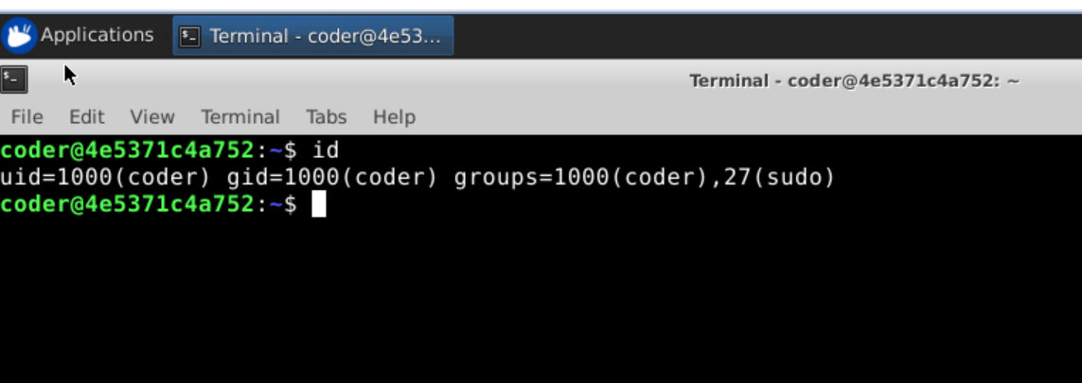
Explanation: Using id command we get currently logged-in username and all groups your user account belongs to. Desired output is shown above.
Answer 2
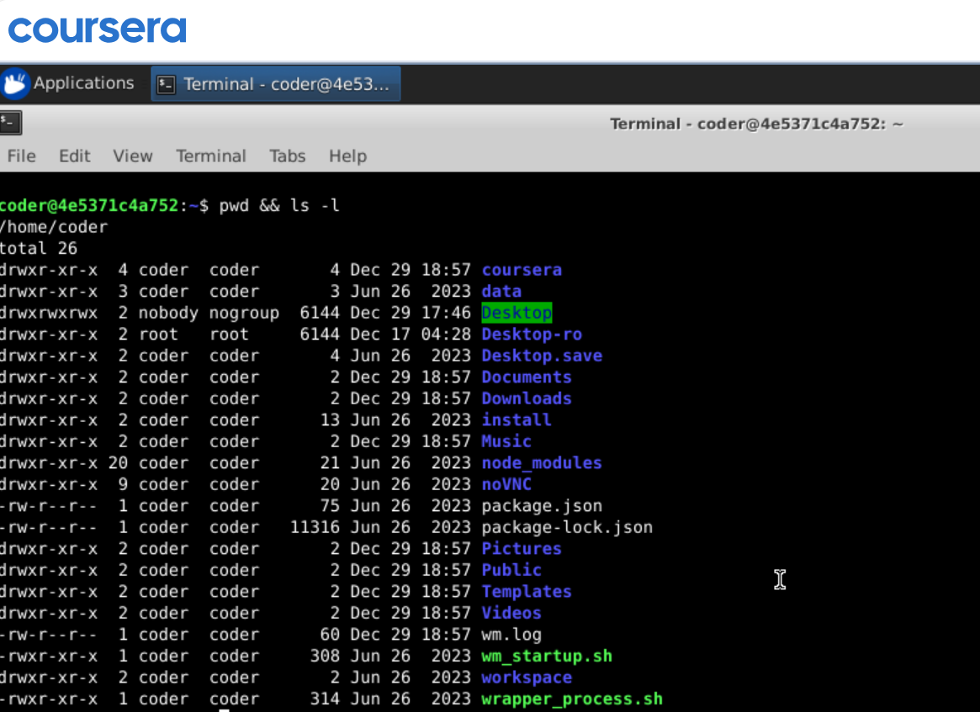
Explanation: Using pwd command which gives print working directory and after that using && symbol which mean run the second command only if first command execute successfully. That how ls -l show us the directories and files inside current directory. Another way to do this running both the command one by one separately.
Answer 3
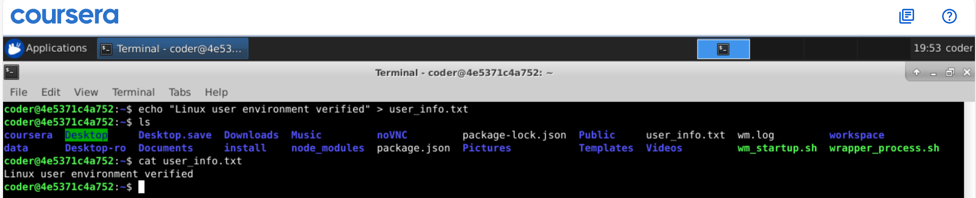
Explanation: Using echo “Linux user environment verified” > user_info.txt, it creates a file name user_info.txt and adds the output come from echo command into the file and later using cat command I am displaying what’s inside the file. By using >> we can append to the file later if we want to add more files to it.
Answer 4
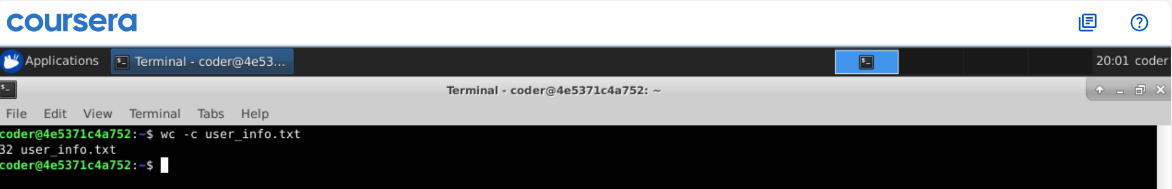
Explanation: Using wc -c user_info.txt, it gives the total character count inside the file with the file name. Running wc without option c will give total character count, line count and word count with the file name.
Answer 5
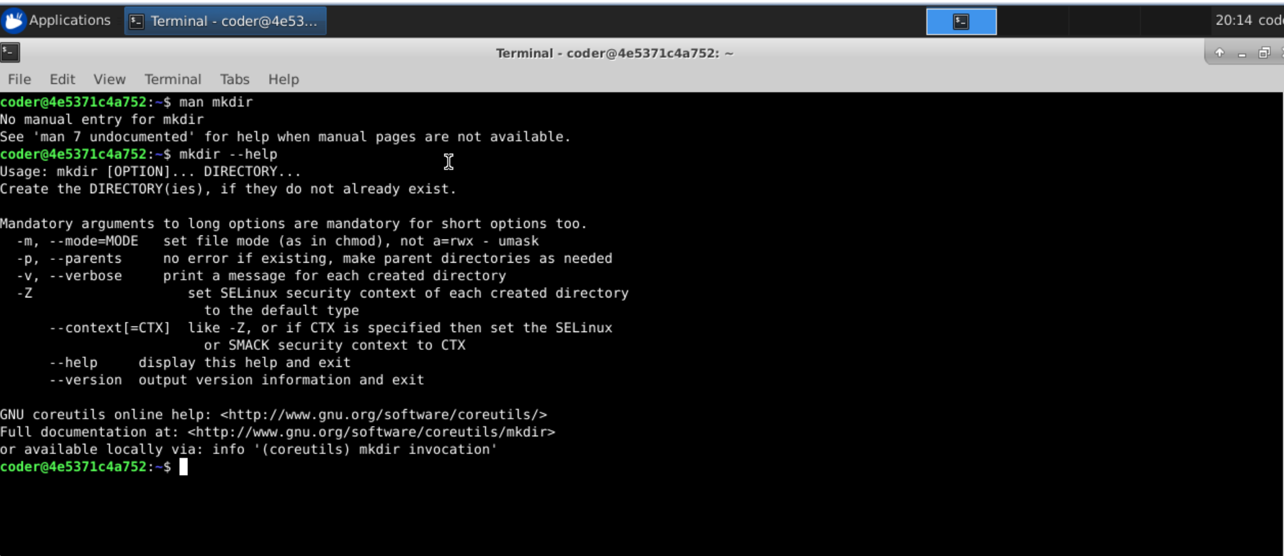
Explanation: The command supposes to be is man mkdir, but for some reason its doesn’t work so the way around is using --help option with the command mkdir this will give you output from man command. Now let’s see option -m with mkdir will allow us to set the permissions for the directory we are creating using mkdir command. Example: mkdir -m 777 e1
Answer 6
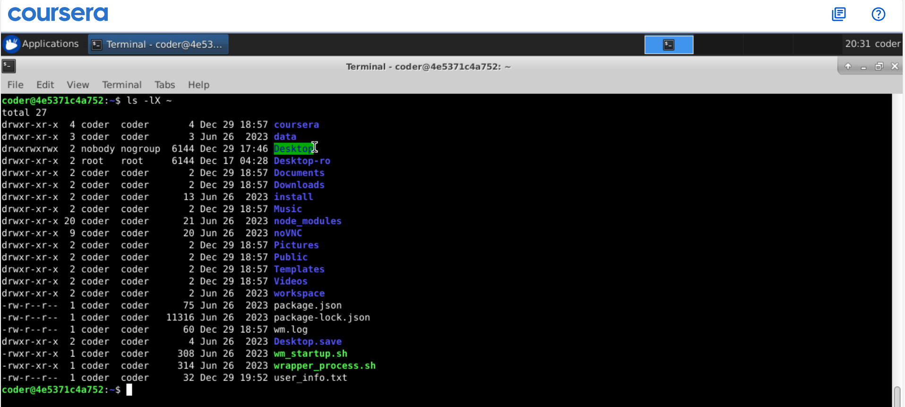
Explanation: Using command ls with option -l and -X give us all the files and dircetories in the home directory with sorted alphabetically and long format. In above case I use ~ which represent my home directory, this can be used if we are running this command from a different directory. Although I am already in my home directory.
Answer 7
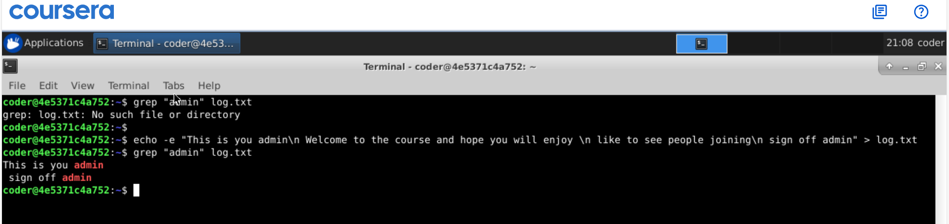
Explanation: As seen using grep command we can show lines containing the matching word, but as there was no file name log.txt got the error message saying No such file exist. But if we create one using echo -e putting some lines of text and do the same command again It would only show the lines containing the text admin
Answer 8
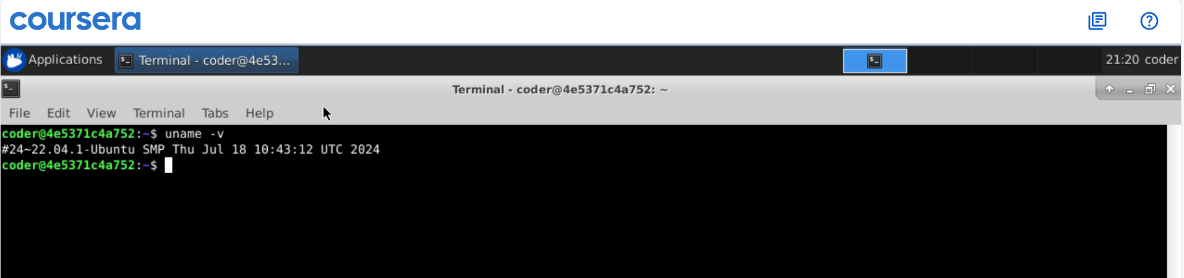
Explanation: So uname with -v option gives us the current version of the kernal and if we want all the info about the kernal we can use -a option. We can also use -r option to get Kernal release version.
Answer 9
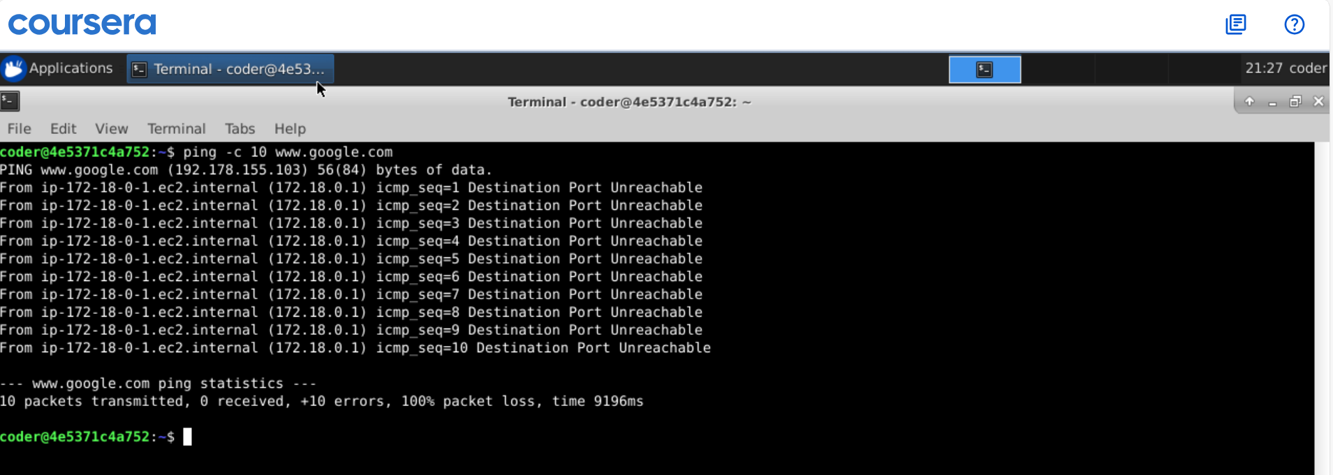
Explanation: So, we tried running ping command which -c option sending 10 requests to www.google.com, but at the end it shows we receive nothing. Also, it says destination port unreachable which show we don’t have network connectivity.

Answer 10
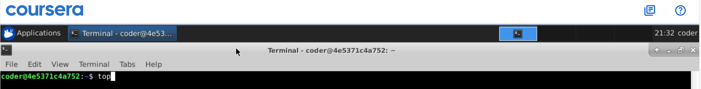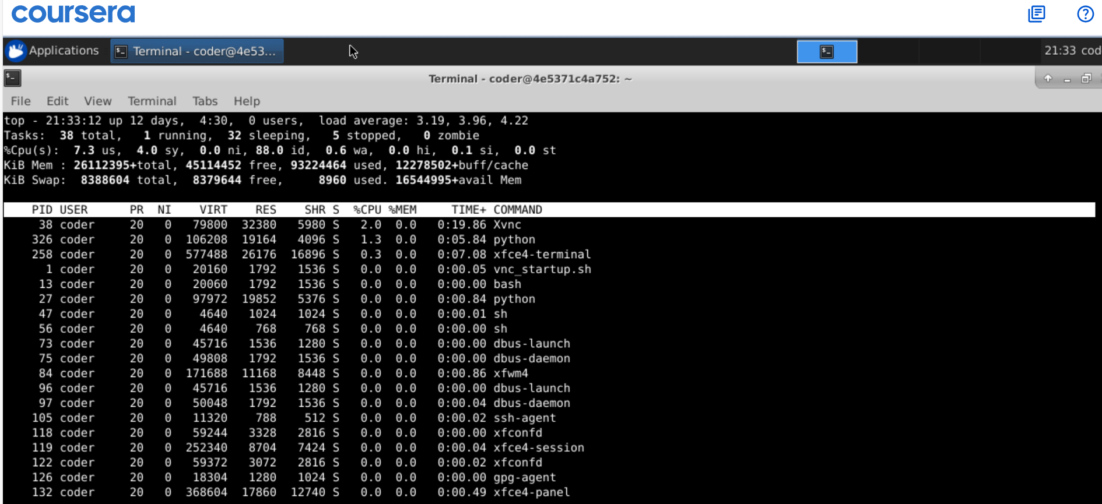
Explanation: So, there are 2 ways to do this one way is to use top command which show the up time at the top line and also show real time current CPU memory usage and all. Secondly, we can use uptime command to get desired result.
Here in the output system is up from 12 days. With 0 users and load of 3.19 in 1 minute depends on the number of cores we have in the system.

